PRESS RELEASE

Embargoed until 27 April 2021, 08.00 CET

EPO-IEA study highlights need to accelerate innovation in clean energy technologies to meet climate goals
- Global patent data shows innovation in the past decade has been increasing faster in low-carbon energy technologies than in fossil fuels
- Average annual growth rate of clean energy inventions in the past decade has slowed compared with 2000-13 level
- Innovation is shifting from renewable energy supply to end-use and cross-cutting technologies such as batteries, hydrogen, smart grids and carbon capture
- Clean energy technologies in end-use sectors such as transport, buildings and industry now account for majority (60%) of all low-carbon energy inventions
- Cross-cutting technologies showed strongest patent growth since 2017
- The rise in patents related to electric vehicles is a key driver of clean energy innovation
- Europe leads overall with a 28% share of global low-carbon energy patents in past decade, followed by Japan (25%), US (20%), South Korea (10%) and China (8%)
- IEA Executive Director Fatih Birol: “Around half the emissions reductions to get to net zero by 2050 may need to come from technologies that are not yet on the market.”
- EPO President António Campinos: “This report is a clear call for action to step up research and innovation into new low-carbon energy technologies, and improve existing ones.”

Munich, 27 April 2021 – The number of patents for inventions related to low-carbon energy technologies around the world grew by an average rate of 3.3% per year in the 2017-19 period, a new joint study published today by the European Patent Office (EPO) and the International Energy Agency (IEA) shows.

The report, Patents and the energy transition: global trends in clean energy technology innovation, finds that except for a slump between 2014 and 2016 the number of global patents in low-carbon energy technologies has been rising over the past two decades. This contrasts with a decline in patenting in fossil fuels since 2015. However, the average annual growth rate of low-carbon energy patents in recent years is only a quarter of what it was a decade ago (+12.5% for 2000-13).

This implies that further innovation, accompanied by concerted policy action, in a wide range of low-carbon energy technologies – from energy production to transmission, storage and end-use applications – is required to accelerate the availability and diversity of technologies, and to bring down costs.

Some of these technologies are already in use on an industrial scale, while others are still at an early stage of development or deployment. According to the IEA, current climate targets can only be achieved by a major acceleration in clean-energy innovation, as many of the technologies required in the coming decades to bring down CO2 emissions are only at the prototype or demonstration phase today.
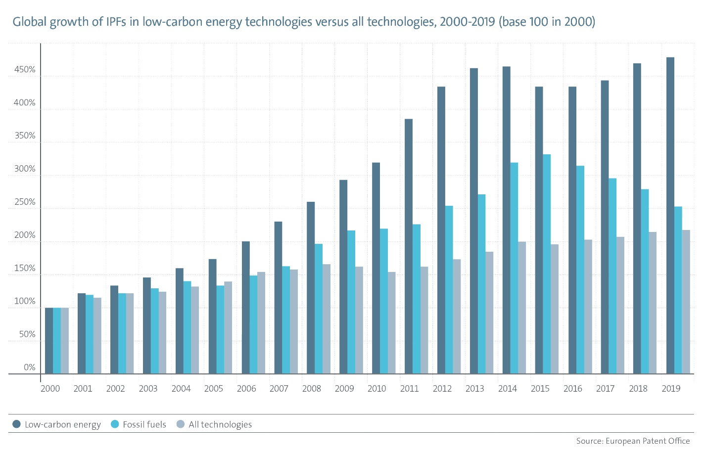
“The energy transition needed to mitigate climate change presents a challenge of enormous scale and complexity,” said EPO President António Campinos. “This report is a clear call for action to step up research and innovation into new low-carbon energy technologies, and improve existing ones. While it reveals some encouraging trends across countries and industry sectors, including in key cross-cutting technologies, it also highlights the need to further accelerate innovation in clean energy technologies, some of which are still only emerging.”
“Around half the emissions reductions to get to net zero by 2050 may need to come from technologies that are not yet on the market,” said IEA Executive Director Fatih Birol. “This calls for massive leaps in innovation, but up until now information on the progress being made has been limited. By combining the complementary strengths of the IEA and the EPO, this report gives us a stronger foundation for identifying and tracking strengths and weaknesses in low-carbon energy patenting, providing a much better picture of the state of the energy transition.”
The changing energy innovation landscape

The report presents the major trends in low-carbon energy innovation between 2000 and 2019 measured in terms of international patent families (IPFs), each of which represents a high-value invention for which patent applications have been filed at two or more patent offices worldwide. As patent applications are filed many months, or even years, before products appear on the market, they are often seen as an early indicator of future technology trends.

Since 2000, businesses around the globe have filed more than 420 000 IPFs in the area of low-carbon energy. These include inventions in three categories: low-carbon energy supply technologies (including renewable energies such as solar, wind, geothermal or hydroelectric); technologies that facilitate more efficient use of energy or fuel-switching (e.g. to low-carbon electricity) in end-use applications such as transport, buildings or industrial production; and “enabling” technologies that cut across supply and end-use or enhance infrastructure to accommodate higher levels of clean energy (including batteries, hydrogen, smart grids, as well as carbon capture, utilisation and storage).

The study finds that patenting related to energy supply technologies, including renewables, has been falling since 2012, reflecting the recent market maturity of a cohort of these technologies – including solar PV – which have not yet been followed by a new wave of improvements to other renewables, such as biofuels or ocean energy. In 2019, energy supply technologies accounted for only 17% of all low-carbon inventions globally.
Technologies related to end-use sectors, on the other hand, have remained relatively stable in recent years, and accounted for the majority (60%) of all low-carbon energy inventions over the past five years, reflecting the major challenge of reining in energy demand across the economy. The biggest end-use sectors for global clean energy patents in 2000-19 were transport (total of 116 000 IPFs in 2000-19) followed by energy-efficiency technologies for industrial production (86 000 IPFs), with some “hard-to-abate” sectors such as metallurgy (e.g. steel production) being particularly dynamic in recent years.
The report also finds that cross-cutting enabling technologies (batteries, hydrogen, smart grids, carbon capture) have experienced the strongest growth since 2017 overall. Their share increased from 27% of all low-carbon energy IPFs in 2000 to 34% in 2019. These cross-cutting technologies are playing an increasingly important role in energy transitions by connecting diverse clean energy solutions, making the energy sector more flexible.

Rise of electric vehicles boosts innovation
A key driver of innovation in the past decade has been the surge in technologies related to electric vehicles, spurred to a considerable extent by advances in rechargeable lithium-ion batteries (see EPO-IEA joint study on electricity storage innovation (September 2020). This trend is also reflected in the ranking of top companies in low-carbon energy technologies since 2000, which includes six automotive companies and six of their main battery suppliers. Also in end-use technologies, the number of IPFs in electric vehicles overtook other clean energy technologies for road vehicles as of 2011 (including those aimed at more efficient combustion engines, as well as improved aerodynamics, weight reduction, or more energy-efficient components and subsystems).

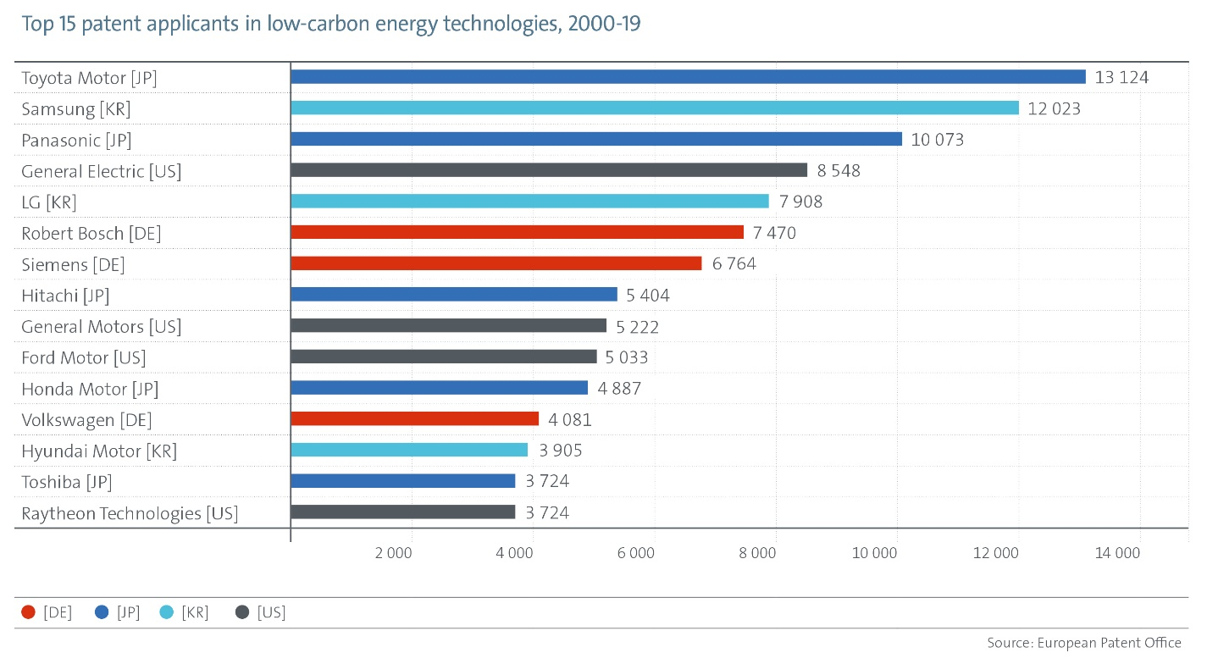

Europe, Japan and US lead, each with different specialisations
Looking at the main regional innovation trends, the study finds that since 2000, European companies and research institutes have led in patenting low-carbon energy inventions, with 28% (12% for Germany alone) of all international patent families in these technologies in the past decade (2010-19), followed by Japanese (25%), US (20%), South Korean (10%) and Chinese (8%) applicants.

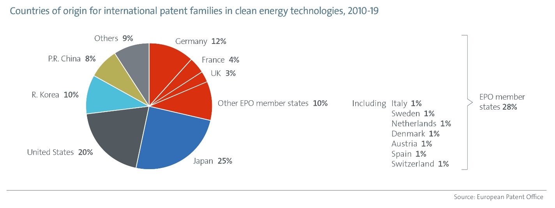

While Europe ranks first in most renewable energy fields and is particularly strong in some end-use sectors such as rail and aviation, Japan leads in electric vehicle technology, batteries and hydrogen, and the US has a technology edge in aviation, biofuels and carbon capture. South Korea's main strengths lie in batteries, solar PV technology, and energy efficiency in industrial production and the ICT sector, while China is also specialised in ICT.
The report also confirms that countries (especially the US and European countries) are collaborating across borders to develop low-carbon technologies, highlighting the potential of international co-operation and knowledge-sharing to further accelerate R&D efforts.
Overall the share of IPFs in clean energy technologies generated by research institutions (universities and public research organisations) has increased (from 6.6% between 2000 and 2009 to 8.5% between 2010 and 2019). Research institutions are especially active in low-carbon energy supply technologies (alternative fuels, nuclear energy and some renewable energies) and emerging enabling technologies such as carbon capture and hydrogen.
Further information
Read the key findings
Read the full study

Notes to the editor

About the report
This is the second joint study compiled by experts at the International Energy Agency and the European Patent Office, following a first joint study on innovation in batteries and electricity storage published in September 2020. The patent analysis in this report takes a much broader perspective looking at the whole landscape of low-carbon energy technologies. It uses the EPO’s patent classification scheme for climate change mitigation and adaptation technologies, which classifies millions of patent documents across a wide variety of climate change mitigation technologies, and has become a widely-used standard for monitoring progress in green technologies across the world. The analysis was done based on international patent families (IPFs) – each of which represents a unique invention and includes patent applications filed in at least two countries or a regional patent office, as well as international patent applications. IPFs represent inventions deemed important enough by the inventor to seek protection internationally, and only a relatively small percentage of applications meet this threshold. This concept can therefore be used as a sound basis for comparing international innovation activities.
About the EPO
With 6 400 staff, the European Patent Office (EPO) is one of the largest public service institutions in Europe. Headquartered in Munich with offices in Berlin, Brussels, The Hague and Vienna, the EPO was founded with the aim of strengthening co-operation on patents in Europe. Through the EPO's centralised patent granting procedure, inventors are able to obtain high-quality patent protection in up to 44 countries, covering a market of some 700 million people. The EPO is also the world's leading authority in patent information and patent searching.

About the International Energy Agency
The International Energy Agency (IEA) is at the heart of global dialogue on energy, providing authoritative analysis, data, policy recommendations, and real-world solutions to help countries bring about secure and sustainable energy for all. Taking an all-fuels, all-technologies approach, the IEA advocates policies that enhance the reliability, affordability and sustainability of energy. The IEA is supporting clean energy transitions all over the world in order to help achieve global sustainability goals.

Media contacts European Patent Office
Luis Berenguer Giménez
Principal Director Communication / Spokesperson
Tel.: +49 89 2399 1203
press@epo.org

